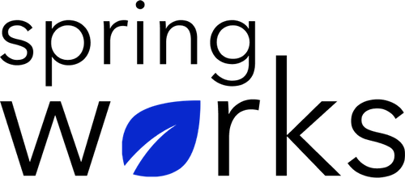
Free Template – Organizational Assessment Survey

Use this survey to find the strengths and weaknesses of an organisation.

Organisational Assessment Survey helps in identifying the shortcomings and strengths of an organisation in the verticals of Human, Operation and Environment. Copy this template to your Google Drive and customize it for your organization.

Communication (to be added as review instructions):

We can only make positive changes when we have the right information. All answers you give will be treated with the utmost sensitivity, and the information will not be used for any other purpose apart from planning and improvement. Please answer this quick survey by <HOUR OF THE DAY> on <DATE>.

Demographic Information:

The following information is requested so that meaningful analysis and comparisons of group results can be made. Please check the circle, corresponding to your answer.

Q: Your Gender:

- Male
- Female

Q: Your Department:

- Marketing
- Operations
- Tech
- Accounting
- HR

Q: Company Service:

- Under 1 Year
- 1-2 Year
- 3-5 Year
- 6-10 Year
- 10-15 Year
Organisational Assessment Questionnaire

To answer clearly what you think or feel about each item, please follow these steps:

- Read each item fully before you start to mark your answer.
- Pick the one answer which most nearly says what you think or how you feel.
- While completing the questions, be sure to read the special instructions which are included.

Choose the answer which is most appropriate (Strongly Agree = 5 and Strongly Disagree =1)

Q: Organisation has a vision statement:

- 5
- 4
- 3
- 2
- 1
- N/A

Q: Organisation’s program delivery is effective:

- 5
- 4
- 3
- 2
- 1
- N/A

Q: I can trust my management and believe what it says:

- 5
- 4
- 3
- 2
- 1
- N/A

Q: Management seeks advice from employees in major decisions:

- 5
- 4
- 3
- 2
- 1
- N/A

Q: Management is supportive and always help whenever needed:

- 5
- 4
- 3
- 2
- 1
- N/A

Q: My immediate manager has effective interpersonal skills:

- 5
- 4
- 3
- 2
- 1
- N/A

Q: Employee problems and complaints are effectively handled:

- 5
- 4
- 3
- 2
- 1
- N/A

Q: New ideas and suggestions are welcomed by the employees for organisation’s improvement:

- 5
- 4
- 3
- 2
- 1
- N/A

(If you agree, please list ideas suggested and approved).

Q: People trust one another in this company:

- 5
- 4
- 3
- 2
- 1
- N/A

Q: It is "easy" to get things done here:

- 5
- 4
- 3
- 2
- 1
- N/A

Q: Communication channels are very open here among management and employees:

- 5
- 4
- 3
- 2
- 1
- N/A

Q: Employee problems and complaints are effectively handled:

- 5
- 4
- 3
- 2
- 1
- N/A

Q: I am proud to work with this organisation:

- 5
- 4
- 3
- 2
- 1
- N/A

Q: I would recommend others to work with this organisation:

- 5
- 4
- 3
- 2
- 1
- N/A

Q: The three suggestions for improving the organisation culture:

i.
ii.
iii.

Q: What else would you like to tell us about?

Many thanks for taking the time to fill in this survey.

